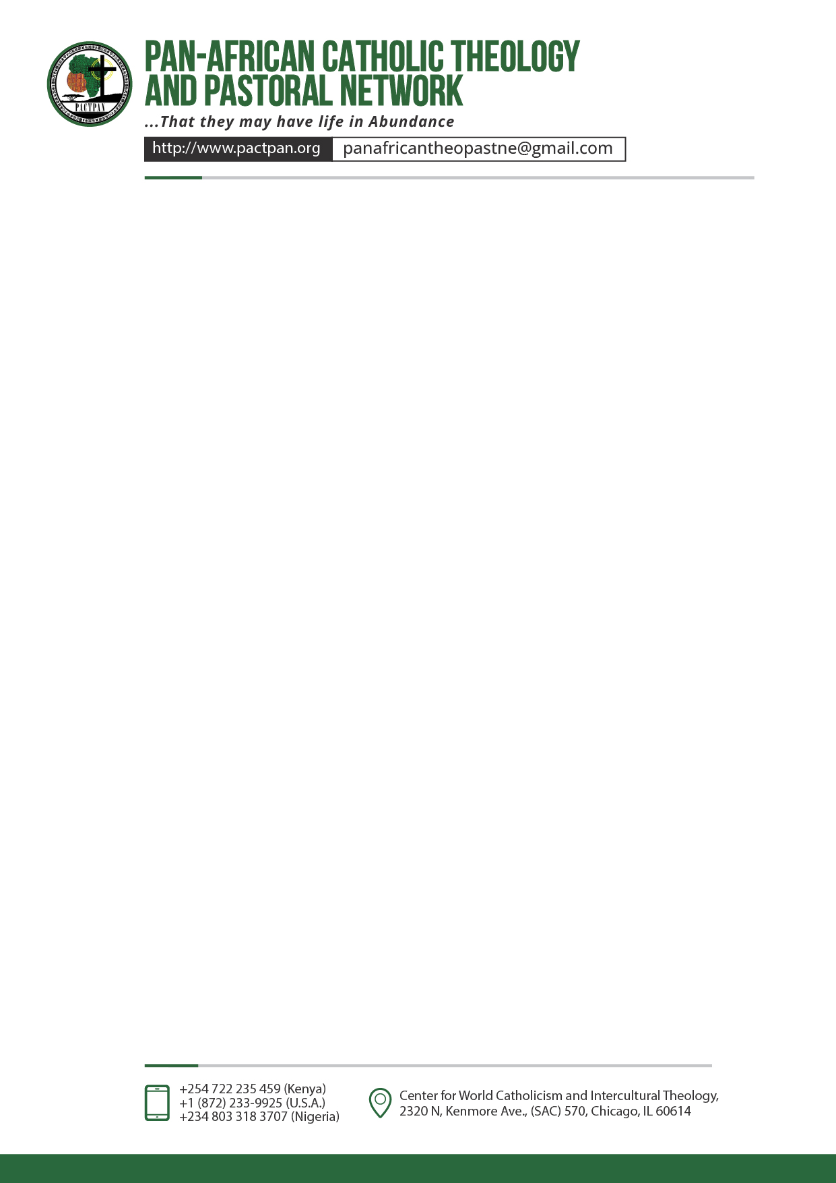
THEME:
Empowering Digital Disciples: Building Bridges of Faith and Social Justice Across Africa

AFRICAN DIGITAL FAITH INFLUENCERS FAITH FORMATION
PACTPAN YOUTH PROJECTS SUMMARY 2024
 | COUNTRY | NAME, PROJECT TITLE, OBJECTIVE | BUDGET
1 | NIGERIA | - EMEKA FRANCIS ONAH- emekaonah8@gmail.com  Phone: 08101724013, 09031356304.  Empowering Artisans through Shoe Making  empower artisans by providing training and resources in shoe making to enhance their skills and opportunities.  - IHUOMA CELESTINE CHUKWUKWADOROM- +2347036164443 ihuomacelestine@gmail.com  Digital Catechism, focusing on Sharing the Catholic Faith through social media  focus on sharing the Catholic faith through social media by using digital catechism to reach and engage a broader audience.  .  - MARTHINA MLUMUN AKIGHIR- mlumunjames024@gmail.com. +234)8167046588  Building a community of faith: Collaborative strategies for catholic digital influencers.  develop collaborative strategies for Catholic digital influencers to build a strong and connected community of faith.  - OKPALA LYNDA UCHENNA- +2348062170300 lyndaokpala3@gmail.com  A Catholic Leadership Development Program. Equipping Catholic leaders with the spiritual, intellectual, and practical skills.  going to equip Catholic leaders with the spiritual, intellectual, and practical skills necessary for effective leadership through a comprehensive development program  - AJAYI JOY OLUWATOMILAYO-+2348164062972 joyajayi2019@gmail.com  Shaping the Church: exploring the significant impact of Canon Law on the Catholic Church and governance.  going to explore the significant impact of Canon Law on the Catholic Church and its governance to shape and understand its role within the Church. | $7000  $1450  $15000  $1000  $1000
2 | BURKINAFASO | - Armel Régis NIKIEMA +22672118635  - BELEMSAGHA JULIE NADEGE WENDKUNI +22673899874  - KAMBOU JULIEN BIENVENUE DEMANGBER-+22670005499 julienkam001@gmail.com  Managing the physical, emotional and social changes related to puberty and adolescence  Going to help manage the physical, emotional, and social changes associated with puberty and adolescence through targeted support and education.  - Combary Lazare +22663685466 lcombary881@gmail.com  Online spiritual formation programs, virtual prayer groups, digital outreach actions.  Offering online spiritual formation programs, virtual prayer groups, and digital outreach actions to foster spiritual growth and engagement.  - DAYAMBA Bindré Roger -+226 65 45 54 51 dbindreroger@gmail.com/dayamba@pactpan.org  Solidarity for all: Promote human dignity and social cohesion to the vulnerable especially IDPs.  Promote human dignity and social cohesion for vulnerable populations, particularly internally displaced persons (IDPs), through acts of solidarity.  - Fr Jean Emmanuel -+22665900973 paroleetvie@gmail.com  Promoting social cohesion and peace among followers of different religions.  Promote social cohesion and peace among followers of different religions through interfaith dialogue and collaboration.  - Marie Constance Eliane Nathalie YAMEOGO - +22675550126  marieconstanceyam@gmail.com  Role of a Catholic youth in nation-building. Focusing on Training, engagement and encounter  Focus on training, engagement, and encounter to highlight the role of Catholic youth in nation-building.  - Nana Wend Yida Gilbert- +22664143535 nana09gilbert@gmail.com  Youth Connection Program. Focusing on the use of digital platform to advocate for Peace and social Cohesion.  using digital platforms to advocate for peace and social cohesion through the Youth Connection Program.  - Éric Ramodgwende OUEDRAOGO - +22674507120  ramodgwendeouedraogo@gmail.com  Youth actions for vulnerable people: Supporting the vulnerable, promoting solidarity  support vulnerable individuals and promote solidarity through youth-led actions. | $1000  $1000  $1000  $1772.7  $1045  $1531.7  $1000
3 | KENYA | - Bonface Wamalwa Nyongesa -bonfacewamalws@gmail.com  +254740693406  Supporting a disabled foundation. showing love and care for persons living with disability in the society.  To show love and care for persons living with disabilities by supporting a foundation dedicated to their needs and inclusion in society.  - Kiragu Claire Wamucii- +254 748 992150 cleowam03@gmail.com  Youth Hub for Digital Evangelization and Connection. Equipping youths with the skills to create and share faith-based content on digital platforms.  To equip youths with the skills to create and share faith-based content on digital platforms to enhance digital evangelization and connection.  - Denis Kioko Wakine – +254759953961 wakinekioko@gmail.com  Jitegemee foundation. Nurturing talents among youths to help them build their future through farming  To nurture youth talents in farming to help them build a sustainable future through the Jitegemee Foundation.  Dominic Mulwa- +254721872552 domulandi2020@googlemail.com  The Holistic Talent Academy. Focusing on the realization of youth talents, baking, shoe polish, bead work.  To focus on realizing and developing youth talents in baking, shoe polish, and beadwork through the Holistic Talent Academy.  - Gichana Mokaya Eleutherius – +254 113 588523 eleutheriusmokaya@gmail.com  Faith Foundations. Focusing on Comprehensive Religious Education Program  To provide a comprehensive religious education program to deepen faith and understanding.  - Ambrose Kilonzo Munyao-+254 700 400 603 +254 704 413 782 Kilonzoambrose7@gmail.com  Faith-Based Education. Leveraging Digital Platforms to Empower African Youth  To leverage digital platforms to empower African youth through faith-based education.  - Albert Kitonga Mutwii-+254717534536 albertkitonga22@gmail.com  Fight Against Drugs and Substance Abuse. The project focus is Providing of education about drug and substance abuse.  To provide education about drug and substance abuse to combat these issues effectively. | $2325.5  $3100.7  $1000  $1000  $1000  $1000  $1000
4 | MALAWI | - Donnie Makoka- +265880999280 donniemakoka@gmail.com  Faith Innovation. Spiritual enrichment, networking and digital mentorship program  To foster networking through a digital mentorship program, to enrich spiritual lives for greater glory to God.  - Leonard Josaya-+265 884 38 81 16 leojosaya@gmail.com  Empowering young people with disabilities, Skills development.  Empowering young people with disabilities through skills development, enhancing their opportunities and independence  - Milliam Kayange -+265 881 83 10 78  mirriamkayange@yahoo.com  Empowering the youth towards sustainable Spiritual and Socio-economic independence. Nurturing spiritual and socio-economic growth in young people.  To nurture both spiritual and socio-economic growth among the youth to guide them towards sustainable independence.  - Vincent Haleke- +265881696336 vinhaleke@gmail.com  Digital Disciples: Empowering Malawian Youth for a Vibrant Church.  To empower Malawian youth through digital discipleship to invigorate the Church. | $1000  $1000  $1036  $1000
5 | SOUTH SUDAN | - Loro Jedion Modi-+234 812 836 0548 modilorojedion@gmail.com  Youth for Christ, spreading the gospel digitally and advocacy for peace  To spread the gospel digitally and advocate for peace to glorify God.  - Marko Nyoro Abal-+211923770444 markonyoro333@gmail.com  Youth Empowerment Program. Creating awareness on causes & Impact of suicide and drug abuse among young people  To create awareness about the causes and impact of suicide and drug abuse to empower and protect the people of God  - Peter GAANIKO Simon-+211 924 663 544  Kpasiakagp6@gmail.com  Addressing Poverty and Hunger in the Context of Faith decline. Food security initiatives and faith renewal campaigns  Addressing poverty and hunger through food security initiatives and faith renewal campaigns to honor God | $1200  $2500  $15000
6 | UGANDA | 1. Ampereza Devis +256772764533 davisampereza@gmail.com/devis@pactpan.org  Nakachwa Lucky Lucy +256703841679  Ninsiima Charlote +256707865741  Empowering youth through Skilling. Youth Training in Baking, Paper Bag Making, Bricklets, Clothing, and Carpentry  Empowering youths to be self-reliance by providing training in various skills, including baking, paper bag making, bricklets, clothing, and carpentry.  - Paul Wasswa Ssebuliba-+256775939015 ssebulibawasswapaul@gmail.com  Digital empowerment for positive change.  Resource hub for faith education, reproductive health, awareness, addiction awareness and support | $1000  $5274
7 | BURUNDI | 1.NIBITANGA Michel +25769685061 m.nibitanga1985@gmail.com  KAMIKAZI Nadia- +25771954640  Online Evangelization School in Burundi: The Digital Disciple on Mission  The two will examine and address the limitations of traditional pastoral communication to enhance its effectiveness in serving God and the community. | $1000
8 | NAMIBIA | Carol Draghoender-+264813950196 caroldraghoender10@icloud.com  Fanning into a flame. spiritual formation through digital content, leadership programs, community engagement  To change the face of the world by foster spiritual formation by using digital content, leadership programs, and community engagement to ignite and nurture faith. | $1000
9
10 | ESWATINI | - Marselina Thandeka-+26878551697 marteesuthu@gmail.com  Bridging Generations in Faith through Compassionate Outreach for the Elderly. Spiritual support, acts of mercy.  To bridge generations in faith by providing spiritual support and acts of mercy through compassionate outreach to the elderly. Develop the Siswati Missal Application | $10000
11 | GHANA | - Linus Kweku Labik-+233262326483 linuskwekulabik@gmail.com  Reconnecting with lapsed Catholics in universities and senior high schools -Using catholic educational resources to provide outreach, mentorship confused Catholic youth  To reconnect with lapsed Catholics in universities and senior high schools by providing outreach and mentorship using Catholic educational resources to guide confused Catholic youth. | $1000
12 | SIERRALEON | - SAMUEL EUGENE KAMARA-eugenekamara89@gmail.com  +23276430101  Recycling: A Christian Approach to Waste Management  To promote a Christian approach to waste management by addressing the interconnections between environmental issues and social justice concerns. | $1000
13 | CONGO BRAZAVILLE | - JEANSTEL LIKIBI DE BERGERAC-+242064954337  bergeraclikibi@gmail.com  Kimia-Essengo non-governmental organization (K’ES)  They will offer continuing professional skills to young people  through specific training.  - Espoir Charmoni LOUKEBA +242056482919 espoirloukeba94@gmail.com  EMICOM (Emile Biayenda Communication)  It will promote evangelization via social networks, inspired by the values ​​of faith and service carried by former Cardinal Emile Biayenda.  - BADI ALFREDINE GINESSE-+2420661157581  Email: alfredinebadi@gmail.com  Non-governmental organization “LISUNGUI”  It involves training and integration of Catholic youth within society by setting up an adequate training center. e.g. plumbing | $1000  $1000  $1000
14 | CONGO DRC | - TSHIBIDI MUSUYA FIFI- +243 992525765 ffimus@gmail.com  YOUCAT Workshops.  To deepen the cultural and social impact of YOUCAT on African "Congolese" Catholic youth. | $1000
15 | TOGO | - APEDO ADJO CLAUDIA-+22892640111 claudiaapedo@hotmail.com  Growth Bridges  Uniting young Catholics for monthly formation to strengthen their faith and understanding of the Gospel.  - BADATANA DI-YANA- +228 91 81 94 47 / 96 02 18 90  immaculeeakpemado@gmail.com  Sex education of young people in the Catholic Church: an approach  holistic and respectful.  To provide accurate information**: Educate young people about the biological, emotional and relational aspects of sexuality. | $1000  $1000
16 | BENIN | - M. B. Camille AGBEVA- +22997768375 camilleagbeva4@gmail.com  Reference Benin Pilgrimage Digital directory of Catholic pilgrimage sites.  To identifying pilgrimage cites and putting accessible online information | $1000
17 | CAMEROON | DJAKIDAO ISAAC-+237698610980 idjakidao@gmail.com  Digital Faith: Awakening young people to digital spirituality.  Opportunities, exploration and integration of faith through digital tools | $1000
18 | GAMBIA | - CECILIA YANGA-+2203222779  The Impact of Broken Homes on the Children’s Wellbeing.  Supportive interventions, therapy, family counselling  - SERGENT GOMEZ- +2203726886 amisasimon@gmail.com  A Self Reliance Church Outstation.  Generating funds to develop the church for sustenance | $1000  $1000

We have 43 projects included in this summary. Our funds are limited to only 35 projects at 1,000 dollars each. We appeal to well wishers to join us in this noble task and support the projects so that all of them can be supported and those whose budget is beyond $1000 can be fully funded and brought to conclusion.

Fr Pascal Mwakio
Youth Advisory Council Chair

